The Fable of the Lost
DATASAL PROJECT

Sidney C. Chen ¹, Miguel Magana ², Camille Merlin S. Tan ³
Department of Electronics and Communication Engineering, De La Salle University
2401 Taft Avenue, 1004 Metro Manila, Philippines
¹ sidney_chen@dlsu.edu.ph
² miguel_magana@dlsu.edu.ph
³ camille_merlin_tan@dlsu.edu.ph

Abstract— This is a design project in partial fulfillment for the course DATASAL in De La Salle University. In applying the data structures learned in class, the group created a text-based game which uses the Binary Search Tree (BST) and List data structures. In doing this, the group used Intellij software in coding the game. This program uses ACM graphics and OPENCV implementation.
Keywords— text-based game; BST; List ; ACM graphics; OPENCV

Introduction
This program is a text-based game that is modernized into the 21st century. The main purpose of this game is made to implement some of the data structures and different libraries into the program. Unlike other games, this game allows the user to use their imaginations and logical thinking in order to survive through the game.

This game is an escape puzzle game, which compose of ten rooms (levels) and has three different endings. For each level, the user will be given starting items in his inventory, in which they can be used in searching for items in the room. All users will start playing the game from room one (tutorial room) and will be promoted to the next room once he completed the task in his current room. Beware every decision made by the user can affect the ending, so he should choose wisely, else might be trapped FOREVER!

Characters
The characters and brief description of each are shown below:
- Drake Armiger- A lineage of legendary clan called “The Lost”. He is in search of the book “Fable of the Lost”
- Nikolas Armiger- Father of Drake
- The Holy Order of Glemour- A group that took the book “Fable of the Lost”.
- Belthael- The fallen angel

Setting
The time and place in which the story happens.
- Time period- 21st century
- Place- Dark Caves of Lysandre

The STORY LINE

Backstory

Drake Armiger was from a lineage of a legendary clan called “The Lost”. For generations since the existence of the Mayans, “The Lost” have been the sole guardians of an ancient book that contains unimaginable power. Drake was next in line to take care of the book, but before his father passed the knowledge onto him, a group called The Holy Order of Glemour found out about the book and wanted to find and destroy the book because they believe that the very existence of the book to be an abomination. His father, Nikolas Armiger, who was then the current guardian of the book, was captured and questioned by The Holy Order. Nikolas, frail of health, died because his heart gave out before he could give the instructions to Drake on where the book is. Drake found out that his father had died after being questioned by the order. Fearing for his and his mother’s safety, they escape, and before sending his mother to his uncle in a distant land, he was able to get exact location on where the book is but not how to get to it. He nevertheless went after the book to preserve it before it falls into the wrong hands.

Prologue
Drake Armiger is in search of the Fable of the Lost, a book which has the secrets of summoning the powers of The Lost - a clan that is able to reanimate and control the dead, finds himself in the dark caves of Lysandre. In order to find this book, Drake must to go into the deepest level, the heart of Lysandre, which is known to people as the "Vantablack Point" because of no one has able to go through the place since no light seemed to be able to penetrate the darkness. He traverses the caves and he reached a cavern with a podium in the center. He notices an uncanny bright light coming from the podium and approaches, being careful of what it is. As he reached the podium, he gasps.

“Finally, the book!” He exclaims.

He lifts the book, caresses the edges and a rumbling sound startles him. He feels the ground tremble and he before takes one step forward, he plummets.

“AAAAAAAAAGGGGGGGHHHHHHHH!”

Drake wakes up, dazed, and then sees nothing. He checks if he’s injured and surprisingly, he is unscathed. The darkness surrounds him. Suddenly, the book emits a sliver of light. He gets the book, opens it up to the page where the light is coming from. As he reached the page, he sees an incantation which says “Quia in Tenebris Lux”. He says these words to himself over and over.

“It doesn’t make sense!” He says.

With his frustration, he shouts the incantation.

“QUIA IN TENEBRIS LUX!”

The room suddenly lit up…..

*Note: The incantation means “Because in darkness, there is light” in Latin.

The GAME

First Room (Nikola’s Torture Room)
This is a tutorial room. The game windows will be displaying actions to choose from. In this room, there are three.

Actions that can be used:
- Check Inventory- Using this action, the user can see what he has inside the backpack.
- Use (name of item)- Using this action, the user can use items currently in his backpack. Note, some items can be used consistently but some can only be used once.
- Search- Using this action, the user can investigate the room, get clues or get items along the way.

Starting items in the inventory:
- Book
- Water skin
- Rope with grappling hook
- Dagger
- Bedroll and blanket
- Coin purse
- A ration of food

Dialog for each action:
- Check inventory- “You currently have: (list of items)”
- Use book- “You open the book. You see words but for reasons, you don’t understand, you can’t seem to understand the words.”
- Use water skin- “You are not thirsty right now.”
- Use Rope with grappling hook- “You don’t need a rope right now.”
- Use dagger- “You have nothing to cut.”
- Use Bedroll and blanket- “You are not sleepy right now.”
- Use a ration of food- “You are not hungry right now.”
- Use coin purse- “You have 17 pieces of silver.”
- Use note- “You immediately recognize the handwriting of your father. The note says” Brace yourself, I’m confident that you will find the book. The book cannot be destroyed, it contai…” To your dismay, blood had smudged the rest of the words in the note.
- Search- “You look around the room. An object catches your eye. You pick up a note.”

Item to find:
- Note from father (can be found by searching)

Note to player:
All actions (Except for the use action. Only the note is important.) are needed to be used before advancing. Sequence is not important in this room as long as the player uses all three actions.

Goal:
Get the father’s message which located at the ______.

Dialog after completing the room:
Immediately, after reading the letter, darkness envelops you and a door, bathed in light, materializes on one of the walls in the room. With a look of determination, you open the door and enter another world, another time. Committed to face whatever the path may lead you.

Second Room (Father’s Study Room)
Dialog:
Your eyes adjust as the light that enveloped you once you passed through the door fades. As you look around, it seemed familiar. You scan the room, checking out the familiar bookshelves and the desk in the middle of the room. As you pace around the room, you realized. It was your dad’s study. There was something weird about the room. There was a painting of the book inside the room. You also notice little ripples across the painting. It seems like it’s calling you to touch it. The book glows as you go near the painting. You then question why you were transported to this room. Suddenly, a flicker of light catches the corner of your eye. You remember that your father has this auspicious cloak with a certain design on the sleeves. Is this a clue on who killed him? Is this a clue about the book?

Actions that can be performed:
- Check Inventory
- Use (name of item)
- Search

Starting items in the inventory:
- same as the staring items in the first room, with addition of the note from father.

Dialog for each action:
- Use Portrait- “You approach the portrait. It really does seem like it’s glowing. The detail of the painting was astounding. You reach out your hand, felt a pulling sensation. It then sucks you into oblivion.”
- Search- “You look around the room. It’s filled with books, from encyclopedias to fiction. You notice something out of the corner of your eye, a portrait. It is a portrait of the book. It seems like it’s glowing.”
- (for other actions it is just the same as in room 1)

Item to find:
- Portrait

Note to player:
Sequence is important in this room. The last action should be “Use portrait” to get to the next room.

Goal:
To be able to use the portrait.

Third Room (Ritual Chamber)
Warning! This is a room where the user can be trapped FOREVER, which is the alternate ending.

Dialog:
You wake up. You still feel the swirling mass of darkness around you. A light suddenly shines ahead of you. You reach for it, yearning that the light is a way out. The light surrounds you, temporarily blinding you in the process. As you get out of your stupor, you realize you’re standing beside a pentagram. In the middle of the pentagram, an ethereal being is chained. The being has long white hair, eyes blazing with undying flame, and black feathery wings. All around you, hooded figures surround the pentagram, swaying in unison, softly chanting something you can’t make out. A shiver down spine gets you thinking.

“What on earth is happening here?” You exclaim.

As you approach the hooded figures you notice an insignia of a blazing lion on the right sleeve. You recognize this immediately. This familiar sense of nostalgia hits you like a freight train, without a doubt, these are your ancestors. With gleaming looks on their eyes, they seem to be focused on the creature in the center of the pentagram. You try to shove them, trying to get their attention, but with no avail. It seems you are just an illusion, an observer. You noticed a tunnel behind the pillar on your left. It seems like a way out however you cannot ignore the feeling that you’re being pulled into the center of the pentagram. What will you do? Will you walk away or let the tugging sensation pull you through the unknown?

Actions that can be performed:
In this room, you have only two options.
- Walk away- “You decide to walk away from all of this. You decide that you no longer need to protect the book since in the back of your mind from the very start, you doubted yourself. You doubted yourself to a point where you believe that you will die at the very first sight of the Order. As you go through the tunnel, darkness once again consumes you, slowly making you fade into something that will forever be damned in this dark, empty, cave. An observer.” You are trapped FOREVER, END OF GAME.

- Approach- “You took a deep breath, deciding to face your fears. You moved slowly into the middle of the pentagram. As you step into the circle, an invisible wall surrounds you and the being of power. The being of power doesn’t move. It stays still, completely and absolutely still. You feel your heart thump against your chest. The creature spoke without looking up, “I am Belthael, an angel of the Almighty tasked to escort the dead to their final resting place, a grim reaper of sorts. And who might you be, mortal?” Shocked that this… angel could sense you much more communicate with you, you a take a pensive step back, Belthael lifts her head and gazes at you, stopping you in your tracks. Her eyes bear down on you, a malicious glint in her eyes.”

Fourth Room (Cavern)
Encounters the fallen angel. The angel cannot be killed nor should be killed. You can only hide and escape.

Dialog:
“The room changes. You’re back to the same cavern where you fell from. You see that Belthael is in the center, waiting for you. Waiting for you to make the first move. You can either choose to fight her or find another way to escape.”

Actions that can be performed:
In this room, you have only two options.
- Fight – “You see that it is either you fight or not. You feel the book getting heavy in your satchel. You opened your bad and see that it wasn’t the book that feels heavy, it was your dagger that your father gave to you when you were young. The dagger seemed to be pulsating, like waiting for something to happen. You encircle your fingers across the handle and rushed towards Belthael, thinking that you would end up in heaven for defeating this abomination. As you were about to reach her, you stop dead in your tracks. You feel the air around get heavy. Belthael starts laughing.

“You are a fool! You try to go against one of God’s fallen angels! You are condemned to eternal punishment and solitude.”

She suddenly grows, grows into a 15 feet giant. She was able to produce sharp blades across her forearms. With one quick swift of her movement, you feel really light. You don’t understand why but you felt the pang of pain in the middle of your torso, you see a straight line, red in color. Your feet suddenly buckle. The last thing you heard was Belthael’s laugh. -END of game

- Escape – “You know from the bottom of your heart that you don’t have the power to take on Belthael but your courage took you here now. You’re ready to face what this abomination can do. She grows sharp blades and becomes 15 feet tall. You think of a plan to escape from her clutches. You then remember the grappling hook you had. You scan the room to check whether you can hook onto something. You see a ledge just behind her. You quickly think of a plan on how to get to the ledge. You run towards her at full speed. She slashes you with the blade but you were smart enough to be careful, dodging with such agility that even surprised yourself. You swing the grappling hook and climb towards ledge.”

Note to player: Use rope with grappling hook to escape from the fallen angel.

E. Fifth Room (Crystal Room
You barely make it out alive from the angel. You slowly stand up and try to figure out where you are. The darkness around the room makes it hard to see but you see a torch on the floor and pick it up. This might help me see better you think to yourself.

*Use torch to proceed

Lighting up the torch you can see all around you. There are rocks of various colors all around you. You examine them closely and they look like crystals but for some reason they are strangely luminous. They react to the torch of the light and reproduce their own light. It’s so weird and fascinating but you can’t get yourself distracted. You keep looking around and discover dead bodies that have turned to just bones with scraps of cloth around them. You start to panic a bit but you decide to investigate a bit.

*Search bodies to find a note

You search the bodies and discovered a note clenched in one of the skeletal hands.

*Use note

You read the note and it says “We’ve been stuck here for days now, our supplies are running low. Cedric has slowly but surely gone mad from being in this place. It seems like something about this place is affecting us. I think it has to be those crystals.”

That’s all the note says and you begin to feel dread seeping into your bones. You push this aside and try to focus. The note said something about the crystals, perhaps there is something there. As you approach the crystals, something jumps out and approaches you. It doesn’t seem friendly and you try to fight it off.

*Fight here, use dagger

You manage to fend off the creature. After you settle your beating heart, you look at the body and it seems vaguely human. You try to ignore it and proceed to the crystals.

*Search crystals

You search the crystals and as you are feeling around, one of the crystals moves and makes a grating sound. A doorway opens up and it seems like the only way out.

F. Sixth Room (Caves)
You proceed through the doorway and it leads into a cavernous space. Your torch doesn’t seem to be able to peer into the roof of the cavern. You look around and it seems completely barren. All you see are rocks and sand all over the floor. You make your way through the caves looking around for a clue but nothing seems to happen.

You find yourself at a crossroads where the cave splits into multiple paths but you dont know which is the right one. You also notice the walls have weird writings on them but you can’t quite make it out. Some of these symbols seem familiar but you can’t remember where you saw them before.

*You can use search writings
*Use book

As you open the book again, all of a sudden you are filled with an understanding of the written symbols. The writing's on the wall tell you which path to take and following these instructions you find yourself in a box like room.

G. Seventh Room (Trapped Room)
You proceed into the room and you are trapped by a stone door that cuts you off from where you just came from. There is no going back that way. The room has four walls and no way out. In the center of the room is a pedestal that has inscriptions on it. Each of these walls has those weird writings on them again.

*search north/south etc. walls each wall has a large symbol on it. Each of the symbols are north “veh”, west “ru”, east “sirt” and south “kane”

You see a riddle on the pedestal. It says:
I always send you in the right direction,
I’m arrayed in black and white,
Ignore me and lose my protection,
No more than two words are in sight.
Veh is the right way.
Ru is the black.
Sirt is white.
Take Kane’s sight.

*use book

You look through the book and it explains that you have to enter a sequence of codes.

*make a riddle here for the pattern (N, W, E, S)
Solve the riddle by pressing the symbols in the proper sequence.

A door opens up and you can now proceed forward into the next area.

H. Eight Room (Tomb)
As you pass through the door, you hear a rumbling sound behind you. You immediately close the stone door behind you but got a glimpse of what was happening inside the previous room you were in. The floor gave way into a great chasm! Luckily, you were able to solve the riddle just in time. As you calm yourself down, you notice that you’re in a large space. You can’t make out how big the place is, but you see a slab of stone in the middle. You warily approach it, seeing more clearly now. It is a tomb. There are engraving all around the tomb which didn’t seem to make sense to you. You suddenly felt something tremble in your bag. It was the book.

*Use book

You flip open the book, and the book suddenly jumps out of your hand. You hear once again Belthael’s laughter. It seemed like your encounter with this fallen angel isn’t over. You notice that the book opened into a specific page which said something in Latin but you understood it like it was your native language.

“You are a fool to have brought the book into this place. This is where we locked up Belthael’s physical entity, the tomb is now emitting a strong force that can rip the book to shreds. Don’t let it reach the book!”

*Get book

You took the book but it won’t seem to close. You feel the same heavenly but hellish feeling wash over you. You run towards the end of the tomb and you look back, you see something forming up on top of the tomb. You hear her laugh again. You see a handlebar at some part of the wall.

*Use handlebar or not. If not, you die from the angel

You run towards the handlebar, quickly pulling it down. A rumble above you took your attention. You see a that the top of the room was opening. A bright light went through towards the tomb. You see that the almost finished entity that was forming on the top of the tomb suddenly vanished. You hear Belthael’s voice cry in pain. As you make your way through the exit, you hear a whisper. “Brace yourself, boy. I will get you as long as you have the book.”

I. Ninth Room (Cavern)
You ran towards the cavern. You see that it was familiar. You then notice the mark you left behind for each room you pass through. You’re almost there! As you reach the last room, you suddenly gasp! People were there, surrounding you. The Holy Order of Glemour has found the place of the book. You’re surrounded, you try to think of a way to escape.

“At last, we have found you. You are the heir to taking the book, am I right? You and your truly are amazing. Having enough power to take Belthael and putting her into the book. Its power should not be seen by human eyes. I will not have it see the light of day!”

You notice that this man was familiar. He was your father’s closest assistants. The most trusted, at that. You think that this man was lying since he had a glint in his eyes. Is he trying to fool the order into destroying the book or use it for himself? A smirk marked his face.
“Did you find the book? Men, seize him! Take his bag and see whether he has found the book.”

*Get book or Get dagger, if Get dagger, he dies.

As the men move closer, you immediately grabbed the book and flipped through the first page. You chant the spell, suddenly draining you of power. A bright light flashed from the book, blinding everyone except you. You run towards the way you came from.

J. Tenth Room (Subway)
As you ran, you came to a fork in the path.

*Choose left or right, if choose left, subway. If choose right, you fall into a chasm and die.

You decide to take the left path. You ran as fast as you can since you hear men shouting from the distance. You see a light at the end of the path you were in. You go to the light. You seem to find it confusing why there was a subway inside the caves. You immediately thought that it was the book’s doing. Magic again played a big part to this. The subway is filled with light. There is a train waiting for him. He rides the train and he lets it lead him into the light.

Conclusion:
You jerk awake. You notice an IV drip connected to your left hand, a constantly beeping heartbeat monitor to your right. You look around, your heart rate monitor beeps frantically as you notice a note in a familiar handwriting smudged with blood on the floor. *fade in black*

Three possible ending of the game:
- Alive- escapes with the book.
- Trapped- gets killed by a monster.
- Dead- trapped forever in the Dark Caves of Lysandre.

IV. Actual Implementation

The game uses two main data structures which are the Binary Search Tree and the List data structure as well as the OpenCV library for the video files and cutscenes. ACM graphics is also used to change the pictures in the program. Each of these is used for a specific purpose in the game. The game follows a linearized storyline that has different outcomes. Each part of the program follows a certain logic and implementation. This will be discussed in parts.

- BST Implementation: The BST used in the program was for storing the various commands the player can enter into the program. This is initialized at the very start of the program. The BST is used for the purpose of storing commands because it is faster to search for commands this way. Any time a new command is entered into the game, the program searches through the program to see if the entered command is valid. If the command is valid, then a certain action occurs. Some actions can be used on multiple levels with different results for each. This will be explained later in the “Actions” portion.

- List ADT: This list ADT is used to store the player’s items in the game. Some higher functions were added into the list ADT for the purpose of the game. Some of which include changing the remove function to accept the item itself instead of its index. Another function added to the program was the search, this allows the program to search if the player has a particular item in his inventory. This was necessary to be added as it was a key part of the code.

- OpenCV Implementation: The library was used to open and play video files in the game. This was done as cutscenes between some levels. This was done by using two classes which are the “ImageProcessor” and the “App” class. These classes enable the program to play the video files. The different video files are included in the “App” class. It should also be noted that the computer used was a 64-bit system and
as a result, some changes to the library had to be made.

- Gameplay: The game follows an almost linear pattern. Each level has certain requirements that have to be accomplished before proceeding to the next level. The logic of this part follows a sequence of actions and uses recursion to ensure that the conditions are met.

- Action: The actions in the game are called recursively and this is done to ensure the conditions are met. Some actions can have the same commands but varying results depending on when and where they are used in the game. This gives the game a more dynamic gameplay and provides more possibilities.

- Counters: There are certain counters in the game and these act as conditions within the game to move the story along and ensure that the condition is properly satisfied. These are used to display hints depending on the level.

- ACM Graphics Package Implementation: The game’s images were designed using ACM graphics. The main title screen was done using this with the font of Ravenclaw which was downloaded online. Some of the images were edited in Adobe Photoshop to give more detail but most images were done using ACM graphics. This was also used to make the coding a lot easier since the programmer does not need to type the whole syntax, just what is needed.

Some in game screenshots:
Starting the program

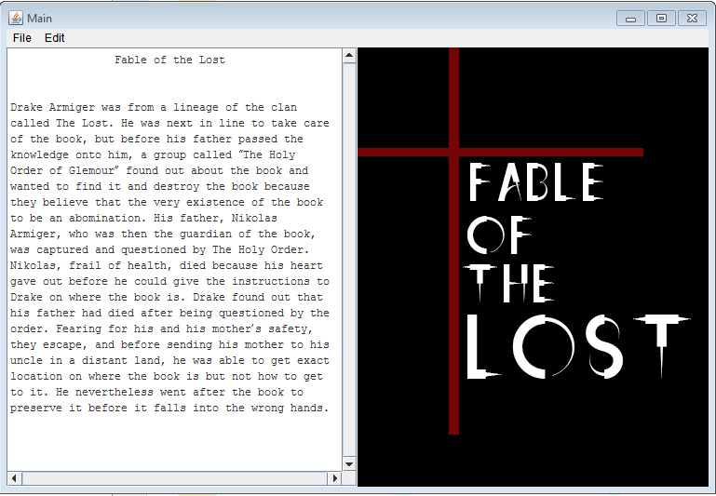
Once the player loads the game, this is how the screen will look like. A backstory will be displayed on the left screen, and a picture on the right screen. The player should press the “Enter button” in order to proceed.

ROOM 1
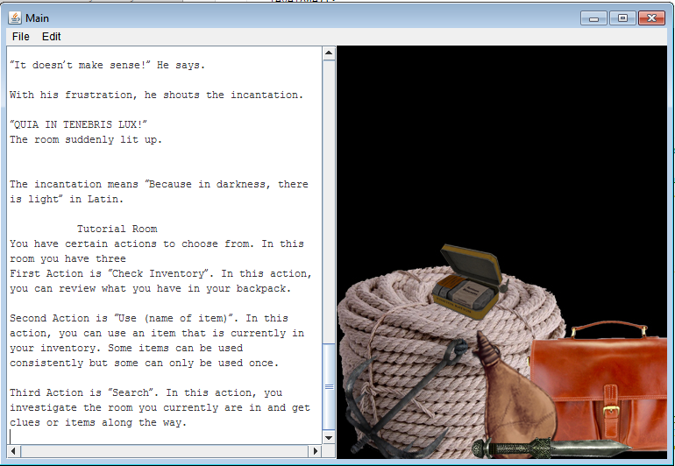

After the backstory have been displayed, the player will start the game, a set of instructions will be given for this tutorial level.

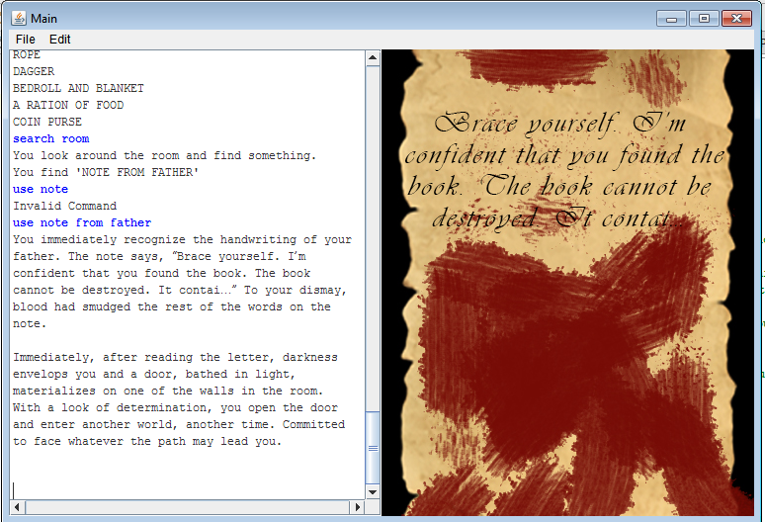

As shown above, the player should be able to type in the complete command in order the program to run correctly. For example, if you type “Use note” it will display an invalid command. Instead, type “Use note from father”. This completes room one.

ROOM 2

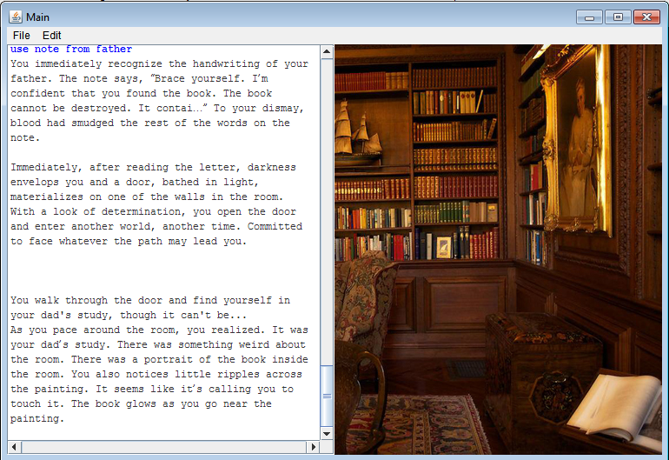After the player completes room one, he will automatically go to the next level (room 2) a new story line and picture will be flashed. These pictures help players to easily visualize the scene.

